Qualitative means __________________________________________________________________________
Synonyms or similar words for qualitative are ____________________________________________________
Quantitative means _________________________________________________________________________
Synonyms or similar words for quantitative are ___________________________________________________
QUALI means ____________________ in Latin QUANTI means ___________________ in Latin
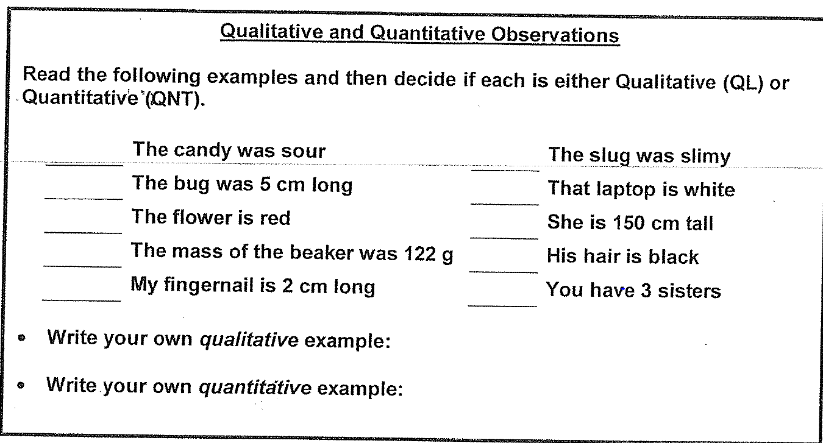

Qualitative means __________________________________________________________________________
Synonyms or similar words for qualitative are ____________________________________________________
Quantitative means _________________________________________________________________________
Synonyms or similar words for quantitative are ___________________________________________________
QUALI means ____________________ in Latin QUANTI means ___________________ in Latin
Also, remember that data is _____________________, so we make ________________________________ not _____________________________________.
What is the difference between an observation and an inference?

Now try your own observations and inferences.
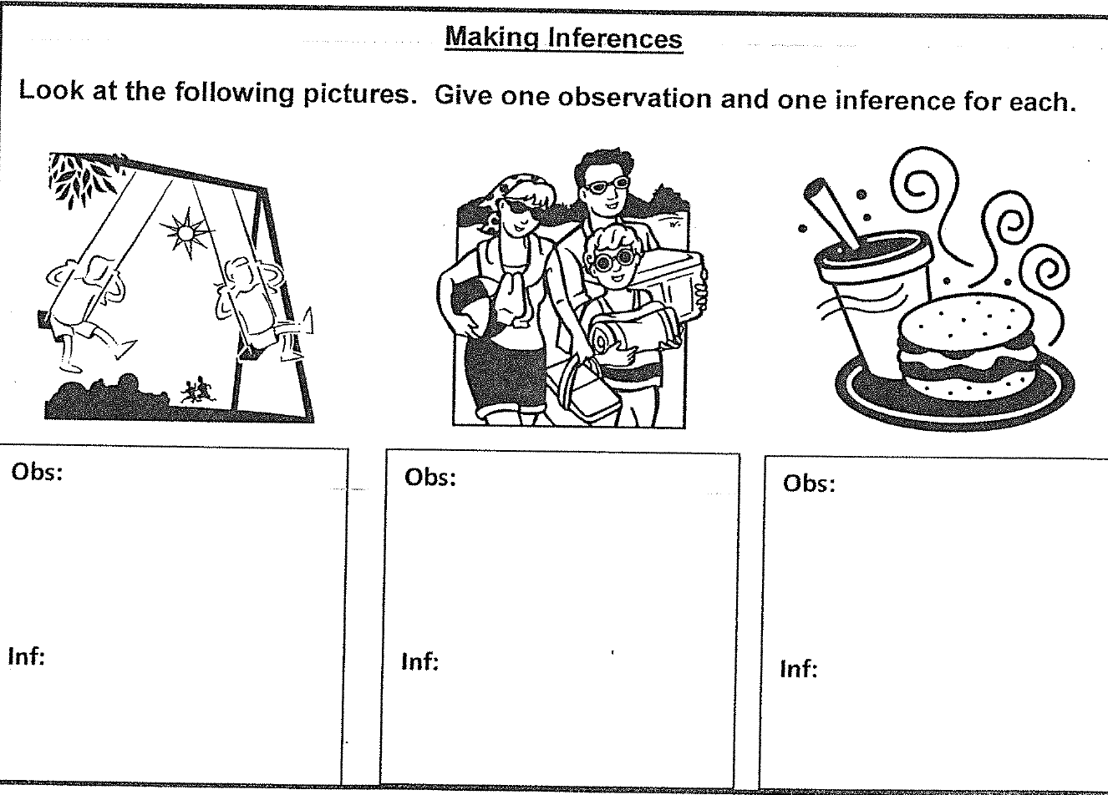

Also, remember that data is _____________________, so we make ________________________________ not _____________________________________.
What is the difference between an observation and an inference?

Now try your own observations and inferences.

