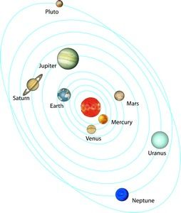Name ___________________________  
STUDENT NOTES—KEEP TO STUDY WITH!

**SYSTEMS**

**WHAT IS A SYSTEM?**

* Two or more **_______________________** to perform a **_______________________** (Job, purpose) and combine to form a whole

**INPUTS & OUTPUTS**

**INPUT**: something that gets put **___________** a system to help it do its **_________**

|  |  |  |  |
| --- | --- | --- | --- |
| *What kind of energy* ***input*** *is needed by these systems?* | | | |
|  |  |  |  |
| car engine  http://us.123rf.com/400wm/400/400/kokandr/kokandr1205/kokandr120500003/13761503-sign-of-a-car-engine-fix.jpg | *C:\Users\Owner\AppData\Local\Microsoft\Windows\Temporary Internet Files\Content.IE5\ARP60ODP\MC900292106[1].wmf*orchestra | http://humanbody.phillipmartin.info/science_digestive_system.gifdigestive system | *C:\Users\Owner\AppData\Local\Microsoft\Windows\Temporary Internet Files\Content.IE5\ZIL14L2G\MM900336627[1].gif*can opener |
| *What kind of energy* ***output*** *is produced by these systems?* | | | |
|  |  |  |  |

* Matter (“**___________**”)
  + Takes up **_________**, has **_________**; made of atoms & molecules
* Energy
* **_____________________**
* ***not the same as a PART of the system

**Possible Energies**:

* Electrical
* Sound
* **______________** (heat)
* Light
* Label the parts of this simple system
* Add inputs & outputs
* Mechanical
* Nuclear
* [](javascript:edit(10032))**_________________** (food is one example; a battery is another)

**OUTPUT**: something that comes **__________ of** a system when it does its job

* Matter (“stuff”)
* Energy
* Information
* ***not the same as a PART of the system

**Sometimes the *output* from one system can become the *input* for another system.**

Example: Apple from a _________ becomes food for ___________.

C:\Users\Owner\AppData\Local\Microsoft\Windows\Temporary Internet Files\Content.IE5\ARP60ODP\MC900297215[1].wmf**HOW DO WE DEFINE A SYSTEM?**

**TYPES OF SYSTEMS**

**OPEN SYSTEM:** both matter and energy **__________________________** (and information)

* *What kinds of* ***energy*** *are inputs and outputs for this system?*
* *What kinds of* ***matter*** *are inputs and outputs?*

**CLOSED SYSTEM**: **_______________________________** enter or leave – the amount of “stuff” stays the same; energy and information CAN enter and leave. (only **________** flows through the system)

* *What kinds of* ***energy*** *can enter and leave this system?*
* *Why can matter* ***not*** *enter or leave?*

*Identify if your picture/drawing above (teakettle) is an OPEN or a CLOSED SYSTEM. Explain why:

**SUBSYSTEM**: smaller parts of a system that have their own **_______** but also work in a **__________** system

* Does your system sketch have SUB SYSTEMS? Identify them here:
* Can you think of other systems that have SUBSYSTEMS?

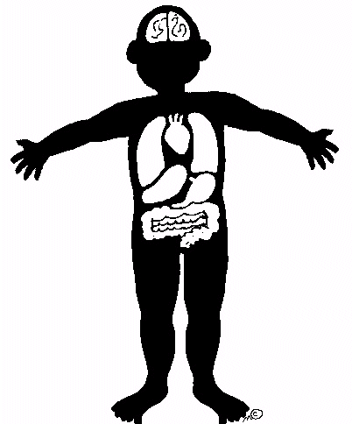**BOUNDARY**: the **________________________________** or surface of a system. It defines what system we are studying.

* Boundaries are determined by the way we **___________** a system and how the parts of a system work **__________________**.
* We (humans) can **______________** boundaries when we want to think about just part of a system. ***For example****, a doctor might consider your whole body system to see if you are healthy overall, or just look at your throat if you have a sore throat.*

C:\Users\Owner\AppData\Local\Microsoft\Windows\Temporary Internet Files\Content.IE5\M6YY00VA\MC900383812[1].wmf**WHY USE SYSTEMS?**

The universe is gigantic & **____________________**; using systems allow us to **_______________** on what we want to **_________________**.