Understanding Human Body Systems TIME: 60-90 minutes total within 2-3 Days
ESSENTIAL QUESTIONS: How does one body system affect one or more other body systems? What factors influence the health and development of these body systems?
EXPECTATIONS: Complete the instructions below in order. You can break it up in 20-30 minute sessions OR do as much as you prefer, then take a break. Since your goal is to be able to gather information to show how human body systems work together to support life, you need to study resources that will help this make sense. If the resources provided in the lesson don’t help you, check out the other resources below instead.
PART 1: Systems of the Human Body (20-30 minutes)
WARM-UP: Answer the three questions after watching this video.
Video Link: Amoeba Sisters https://www.youtube.com/watch?v=gEUu-A2wfSE&vl=en
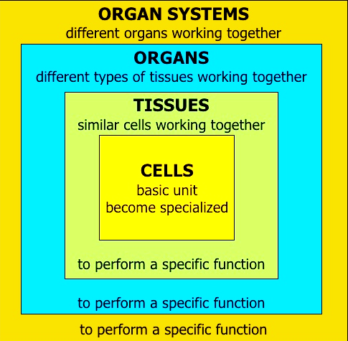
Answer these questions to prepare for what you are about to learn. (It is okay not to know the answers yet. Thinking about them first helps prepare your brain for learning.)
Q1: Why are cells important in the human body?
Q2: Why does the human body have so many systems?
Q3: What could happen to the human body if one system shuts down?

RESEARCH: Read the article and complete the directions below.
Article Link: Body Systems Work Together https://www.mrsd.org/cms/lib/NH01912397/Centricity/Domain/245/body%20systems%20work%20together%20reading.pdf
Question # | Answer | Question # | Answer
1 |  | 5
2 |  | 6
3 |  | 7
4 |  | 8
Next: Complete the eight (8) multiple choice questions after the reading to evaluate your understanding of human body systems so far. Write or type your answers in the spaces below.

Next: Select two of the human body systems (there are 11 to choose from!) to research, then fill in the Venn Diagram below. Show the differences and similarities between these two systems. An example would be to compare/contrast the Muscular System and the Skeletal System.

- _______________________ System 2. ______________________ System

REVIEW: Try to answer the questions again. (They should make more sense now).
Q1: Why are cells important in the human body?
Q2: Why does the human body have so many systems?
Q3: What could happen to the human body if one system shuts down?

FINISHED EARLY? GOT QUESTIONS? NEED DIFFERENT RESOURCES?
Article Link: Study Guide to the Systems of the Body
https://www.acls.net/study-guide-body-systems.htm

Video Link: The Human Body | Facts About the Parts of the Human Body System
https://www.youtube.com/watch?v=e_1utfWwdD4

PART 2: Factors that Influence Human Body Health & Development (20-30 minutes)

RESEARCH: Read these articles to look for examples of how exercise, nutrition, sleep and stress affect the human body. Write notes and questions as you go. Then answer the three questions.
How Diet, Exercise, and Sleep Affect Brain Power:
https://iachievelearning.com/2018/01/how-diet-exercise-and-sleep-affect-brain-power/
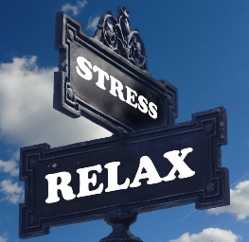
Relaxation & Stress: https://www.wellbeingpeople.com/2019/04/15/why-relaxation-is-so-important/
Q1: How does your fitness level impact your health?
Q2: How do your nutritional choices (food, drink) affect your health?
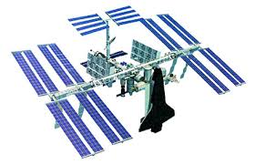
Q3: What roles do sleep, stress and relaxation play in how well your body functions?

Check this out!
What Happens to the Human Body in Space? https://www.youtube.com/watch?v=1xQx5d0RI3M

PART 3: Human Body Response to Exercise (20-30 minutes)
PRACTICE: Examine the interacting relationship of the circulatory and respiratory systems during exercise.
LEARNING TARGET: Write evidence with reasoning to complete a CERER and send it to your teacher.
Three students are learning how different body systems are affected during exercise. For an experiment, they decided to gather data about how exercise affects their heart rate (circulatory system) and breathing rate (respiratory system). They measured their heart rate (bpm = beats per minute) and breathing rate (breaths per minute) at rest, after walking up and down three flights of stairs, and after running up and down three flights of stairs. The results are shown in the following table:
 | Heart Rate |  |  | Breathing Rate
 | At Rest (bpm) | Walking (bpm) | Running (bpm) | At Rest (breaths/min) | Walking (breaths/min) | Running (breaths/min)
Student 1 | 70 | 73 | 122 | 12 | 12 | 16
Student 2 | 74 | 75 | 135 | 14 | 16 | 21
Student 3 | 68 | 70 | 128 | 12 | 13 | 18

Evaluate the information in the paragraph and the data table, then support or refute the following claim:
“The circulatory system and respiratory system are affected by exercise.”
Write a CERER: Be sure to use two pieces of evidence from the data table to support your claim, and two reasoning statements to describe how your evidence supports this claim.

REVISED THOUGHTS: Complete these reflection questions to see how much you have grown your learning and email your teacher a copy so they know how to help you.
Q1: What was surprising about human body systems?
Q2: What did you already know but see in a new way?
Q3: What do you still need help with?

AND NOW FOR SOMETHING COMPLETELY DIFFERENT…

Video Link: Liquid Sand Hot Tub - Fluidized Air Bed https://www.youtube.com/watch?v=My4RA5I0FKs&t=213s

Video Link: Drinking Nasty Swamp Water (to Save the World)

https://www.youtube.com/watch?v=6qZWMNW7GmE

Video Link: Can You Solve the Bridge Riddle? https://www.youtube.com/watch?v=7yDmGnA8Hw0

