UNDERSTANDING HOW EVIRONMENTAL FACTORS INFLUENCE GROWTH

TIME: 60 minutes

ESSENTIAL QUESTION: How do the genes of an organism influence its growth as compared to its environment?
EXPECTATIONS: Complete the instructions below in order. Since your goal is to be able to use evidence and reasoning to describe how genetic factors influence growth versus environmental, you need to study resources that will help this make sense. If the resources provided in the lesson don’t help you, check out the other resources below instead.
PART 1: WARM-UP (15 minutes) Watch this quick video then answer the questions
Video Link: https://www.youtube.com/watch?v=0cuO5OSDMbw
Answer these questions to prepare for what you’re about to learn. (It’s okay not to know the answers yet. Thinking about them first helps prepare your brain for learning).
Q1: What factors influence how tall or how smart a person will be?
Q2: How do genetic factors differ from environmental factors?
Task: Make a sketch of things that influence your height. Refer back to the video if you forgot what they were.

PART 2: (20 minutes) Read the article, "Is Intelligence Hereditary?”, and complete the tasks below.
Article Link Here: https://www.scientificamerican.com/article/is-intelligence-hereditary/
Task 1: Add to your previous sketch and include factors that influence intelligence.
Task 2: Describe how important our ENVIRONMENT is in our growth and development.

PART 3: (25 minutes) Twins & Environment - Twins have the same DNA, so how do they end up with differences? Watch this video to explore this concept and follow the directions below.
Video Link: https://learn.genetics.utah.edu/content/epigenetics/twins/
Task1: Make a list of some of the environmental factors that may affect twins as they age.
Task 2: Then, explore the effect of the environment with a simple simulation:
- You may need to open the simulation in Internet Explorer (it requires Flash Player)
- Read about how a rat mother’s care influences her babies: https://learn.genetics.utah.edu/content/epigenetics/rats/
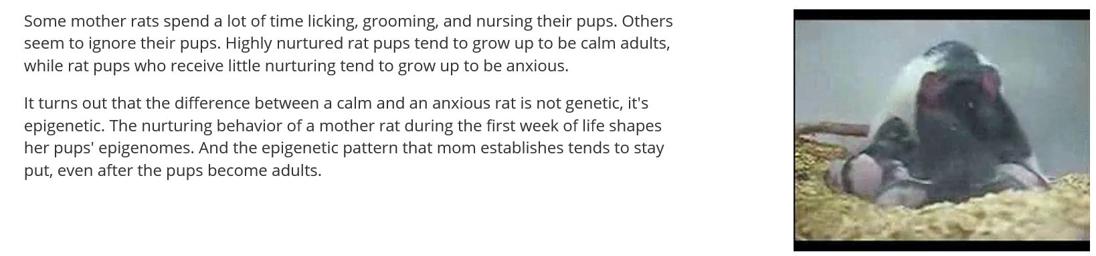
Next, try one or both simulations to investigate this idea – How does a mother rat’s care of her babies influence their health? You do not have to be able to explain the exact genetic mechanisms of this concept.
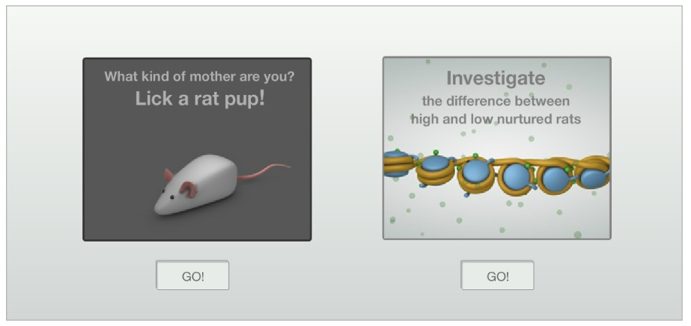
Feel free to explore the other information on this page as you have time.
Try to answer the questions again. (They should make more sense now).
Q1: What factors influence how tall or how smart a person will be?
Q2: How do genetic factors differ from environmental factors?
Teachers should collect student data from students on these topics/questions in any way they choose.

FINISHED EARLY? GOT QUESTIONS? NEED DIFFERENT RESOURCES?
Video: PBS Nova “Ghost in your Genes” https://topdocumentaryfilms.com/the-ghost-in-our-genes/

