Name: Date: Science
BOTANY INTRODUCTION
Plants are essential to our existence! As you learned, plants bring energy into themselves through photosynthesis. Also, they bring in carbon dioxide and release oxygen (and a little carbon dioxide. Phototropism is when plants bend themselves to grow towards the light because they need the light to photosynthesize.
There are six main reasons that plants are important. Everything we eat comes directly or indirectly from plants, so plants are important forfood. Oxygen is brought to us by plants and is a byproduct of photosynthesis. Plants regulate the water cycle because they help distribute and purify the water on this planet, as well as helping to move water thought the soil to the atmosphere in a process called transpiration. Plants make up the backbone of all habitats. Species such as fish and wildlife also depend on plants for food and shelter. Plants store carbon and have helped to keep much of the carbon dioxide produced from the burning of fossil fuels out of our atmosphere, so they help keep our climate regulated. And finally, did you know that one-quarter of all prescription drugs come directly from or are derivatives of plants? Four out of five people in the world today rely on plants for primary health care because our plants provide us with medicine, much of which has not even been discovered yet!
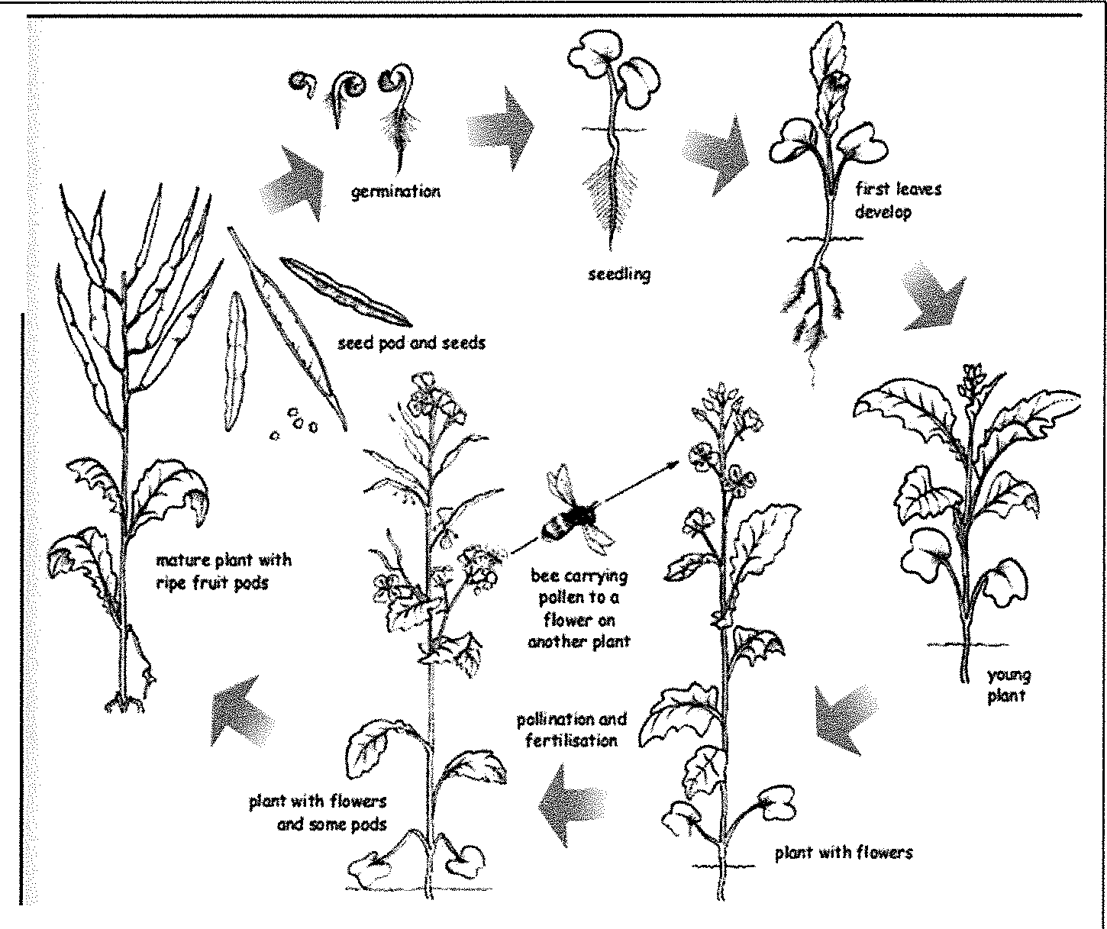
We eat six main parts of the plant in our daily diet. Those parts are the seeds, roots, stems (also called shoots), leaves, flowers, and fruit of a plant. The seeds, of course, are the new or 'baby' part of the plant. The roots anchor the plant into the
ground, take up water through capillary action, and bring nutrients to the plant as well as storing carbohydrates. . The stems hold the plant upright, and the leaves photosynthesize, bringing energy to the plant. The flower of the plant attracts the pollinators such as bees, dragonflies, and other insects. When the plant has been pollinated, the flower petals no longer need to attract bees, so the petals fall of, thus allowing all the energy of the plant to go into growing the fruit. Inside the fruit are the seeds, which will eventually drop to the ground and the process, will begin again! Study the diagram of the
plant cycle of a plant in the diagram.

We use many parts of the plant in our diet! See if you can put the following plants into the correct categories!

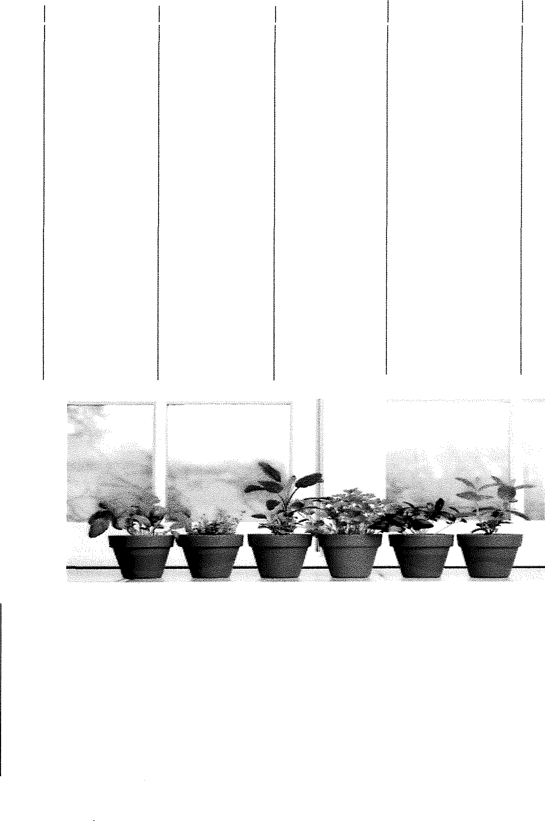
SEED ROOT
STEM
LEAF FLOWER
FRUIT

CABBAGE APPLE BROCCOLI CAULIFLOWER RICE
CELERY
WORD GARDEN
CHERRY POTATO
PEAS RADISH
PARSLEY BEETS
BANANA TURNIP
SPINACH WHEAT
BASIL CORN
LETTUCE ASPERAGUS CARROT RHUBARB STRAWBERRY
PEANUT

