Exploring the Data Behind Brain Injury

Part 1: TBI on the Web—What Are People Looking For?
Critical Questions: Things to think about as you work

- How do people search for TBI information on the Internet?
- Does the search term a person uses affect the kind of information they get?
- What kinds of news stories are written about TBI?
- How can web search information help you study TBI?

The Internet is a place where anyone can get information on almost any topic. Most people’s first stop when they are looking for information is a search engine. One of the most popular search engines is Google, with over 88 billion searches completed worldwide each month. One interesting thing about Google is that they keep track of what terms (or keywords) and topics people search for, and allow anyone to view this information through a site called Google Trends. Getting to know how to use Google Trends can help you get a better idea of what matters to people when they go online to search for information about TBI.

Step 1: Getting there

Open a web browser and head to:

Step 2: The Search Bar

Google Trends provides you with many different ways to search for data.
Click on “Explore” and take a look at the Google Trends search bar:

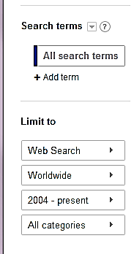

There are a lot of options, and the more you explore Google Trends, the more comfortable you will be with using these options to get the information you are interested in. For now, begin with the default setup shown above.

To explore the kinds of information Google Trends can provide, type in the TBI search term: Concussion. You should see results that look something like this:
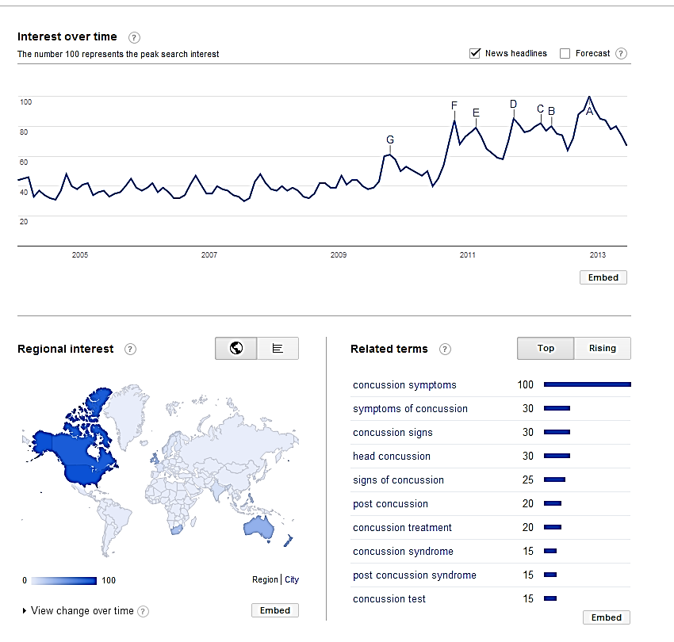

There is a lot of information presented here. Now it’s time to explore what all of it means.
Step 3: What Google Trends Has to Say About Concussions

Keep your search results for “Concussion” up on the screen to answer the questions below:
1. What are the top categories listed for the term “Concussion”? (List up to 4)

Google Trends takes any search term you enter and classifies it into a related category. These categories are broad themes like “Sports” and “Business”. They can be found when you click on the “All categories” tab of the search bar shown in Step 2.

Category

2. Do the categories make sense? Explain why you think each category does or doesn’t fit the search term.

For your “Concussion” search, look at the section labeled “Interest over time”. This is a graph of how many searches have been done for “Concussion” over time.

3. Sketch the interest graph for “Concussion” below:

2004 | 2005 | 2006 | 2007 | 2008 | 2009 | 2010 | 2011 | 2012 | 2013

4. Do you see any patterns, trends or sudden changes in the interest graph? How would you describe your observations to someone who can’t see your graph?

Ask yourself:
- What might cause changes in interest?
- Is there a pattern to how the interest changes? Does it repeat over time?
- What do any sudden changes in interest look like? How long do these changes last for?

5. What are the top four news headlines selected for “Concussion”?

One way to get extra information about the interest over time graph is to look for any related news headlines displayed as letters on the graph. These stories are randomly selected by Google Trends whenever the interest of a search term peaks. These represent some of the news information available about your search term.

In the box below, list the headline, date, and the source. Hover your mouse pointer over a letter on the graph to get the information you need.

For the category column, pick which of the categories from question 1 best fits the subject of the article based on the headline.

Date | Headline | Source | Category

6. Does the top “concussion” category match the categories you selected for the news headlines? If not, why might it be different?

Ask yourself:
- How might the audience for a news article about TBI be different than the audience for an informational website?

Below the interest over time graph is a list and map of regional interest. This information shows what countries of the globe search the most for “Concussion” compared to all other searches from that country.

7. How might you be able to explain the pattern of countries that show the most interest in searching for “Concussion”?

Ask yourself:
- What might these countries have in common?
- How might this affect the kind of Google Trends information I get about this search term?

Google Trends also shows you related searches to “Concussion”. Google provides two lists: “Top” Searches and “Rising” Searches. “Top” Searches show related terms that share a high level of interest with the search term you selected. “Rising” Searches are related terms that have shown a sudden increase in popularity (shown as a percentage). Clicking on any term will show you its Google Trends data.

8. How might you be able to use “Top Searches” and “Rising Searches” to improve how you search for information about TBI?
Ask yourself:
- How might rising searches be linked to recent events?
- How might the public’s perceptions of TBI determine what terms are used most?

Finally, Google Trends lets you compare multiple search terms. To see how this works, click the “Add search term” button below your “Concussion” term and type in “Traumatic Brain Injury”. Your search bar should look like this:
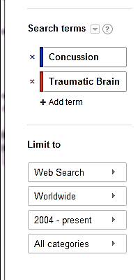

9. Sketch the interest graph for “Concussion” compared to “Traumatic Brain Injury” below:

2004 | 2005 | 2006 | 2007 | 2008 | 2009 | 2010 | 2011 | 2012 | 2013

10. How might you explain the difference between the interest levels?

Ask Yourself:
- How do these terms relate to each other?
- Why might someone searching for TBI information use one term more than the other?

Step 4: Pick Your Own Search Term

11. What are some possible search terms you could use to find out more information about TBI? List 4 below and support why you chose them.

Ask yourself:
- What are the major concepts we have discussed so far?
- What kinds of TBI information am I interested in?

Search Term: | Why use this term?

Part 2: Data, What is it Good For?

Critical Questions: Things to think about as you work

- Why is it important to collect injury data about TBI?
- Who is collecting information on TBI?
- How does the media use TBI data? Is it effective?
- How can I use TBI data to generate my own questions?

Data collection about the frequency and type of traumatic brain injuries is critical to a better understanding of the source of TBI, how to create effective prevention, and how to improve treatment. But where does this data come from? Many governments and organizations track TBI data and make it publicly available for everyone. While the collection of data is important, just having data does not solve a problem. How the data is presented in the form of claims or statements can make a big difference in who pays attention to the information. Using a public TBI dataset you will get a chance to create your own data-based claim.

Step 1: Claim, Evidence, and Reasoning

Most scientific research starts with a good question. But collecting all the data you need does not mean that you will be guaranteed a good answer. An effective answer (or claim) to a scientific question contains both evidence (from the data) and reasoning. Look at the table below to become more familiar with the parts of an effective scientific explanation:

Claim | A statement that solves the problem or answers the question being investigated.
Evidence | The data that is used to support the claim
Reasoning | Explanation of why the data counts as evidence and how it supports the claim.

1. Locate the claim, evidence, and reasoning in the statement below.

In the passage, circle the claim, underline the evidence, and draw a box around the reasoning.

Text adapted from: Study: (2011, April). NHL players had 559 concussions from 1997-2004. USA Today.

A new study finds that the amount of time NHL players missed because of concussions increased from 1997 to 2004.
The report published Monday in the Canadian Medical Association Journal, the largest and most detailed analysis of concussions in hockey, examined physician reports from seven regular seasons. There were a total of 559 concussions during regular-season games, a concussion rate of 5.8 for every 100 players, or an estimated 1.8 concussions per 1,000 player-hours.
"We found some interesting trends — one being a gradual increase in post-concussion time loss over the seven years of study," said lead author Dr. Brian Benson of the Sport Medicine Centre at the University of Calgary's faculty of kinesiology. "That may be due to the concussions being severe or physicians being more conservative in their return-to-play decisions."
Benson said the NHL was looking at the data closely.
Of the 529 cases in which lost time was recorded, 31% involved players missing more than 10 days of competition. In 11% of those cases, players continued to play and then later reported symptoms to medical staff after the game.
The highest concussion rate recorded was 7.7 per 100 players in the 2000-01 regular seasons, while the lowest was 4.6 in 1997-98. The last year covered by the statistics — 2003-04 — saw a rate of 4.9 per 100 players.

2. How did the sample text use evidence to support its claim?
Provide 3 examples below:

- ________________________________________________________

- ________________________________________________________

- ________________________________________________________

3. Where did the evidence come from?

4. Do you think the article did a good job of providing reasoning for its claim? Support your answer with examples from the article.

Step 2: Exploring the Data
Many governments and organizations make data related to TBI available to the public. The Project NEURON TBI data explorer has been designed as an easy way to find and examine public TBI data. The questions below will introduce you to the data available, and get you ready to make your own claim based on the data.

First open a web browser and head to:

5. What kinds of data are available on the Project NEURON site?

Read through the summaries for each dataset on this page to complete the table below:

Dataset Name | Summary of Available Data

6. Finding an article to investigate:
Using the search terms you prepared in Part 1, Step 4 as guide, explore Google Trends (http://www.google.com/trends/explore) or Google News (http://news.google.com/) for a TBI news article that is related to the information found in one of the datasets on the Project NEURON website. Print the article (if possible) and fill out the information below:

Date:________________ Author:___________________________________

Article Title:____________________________________________________________________

Source Address:_________________________________________________________________

7. Does the article you selected make any claims? If so, what are they? If not, could you create a supporting claim?

Ask yourself:
- Does my article make a claim that I can support or verify with the Project NEURON datasets?
- If my article doesn’t have any claims, how could I use the Project NEURON datasets to create a claim that supports the article?

Step 3: Using the Data
Now it’s time to use the data available in the Project NEURON datasets. Follow these steps:

- Decide which data subset would contain information you could use to further investigate the claim in the article you chose above. Which data subset would help to support or refute the article’s claim? Circle one:

Games and Practices With Associated Injury Rates
Injury Rate By Game Type and Season
Body Regions Injured Most Often by Game Type

- View the instructional video on the Dataset Graphing Tool page. This video will demonstrate how to use the tool to select data of interest, filter the data, and then graph the data.

- Click on the link to the data subset you have chosen to use to investigate the claim in the article. Then, follow the instructions from the video to select, filter, and graph the data you are interested in.

- Print or save your final data sheet once you have generated a graph of the data you want.

Step 4: Claim, Evidence, and Reasoning.
8. What is the CLAIM you are investigating from the article you chose in Step 2 (Questions 6 & 7)?

9. What is the EVIDENCE that you gathered? Explain your graph and discuss your findings.

10. Explain your REASONING. Explain how your evidence supports or refutes the claim in the article.

