Follow the links in each slide of the matching Power point to find the answers. Email me a screenshot of this worksheet TODAY ONLY & get a homework pass reward!

SLIDE 1 “The Brain & Its Parts”
- How many parts make-up the central nervous system? __________________________
- What are brain cells called? _____________________________________________________
- Are there any other special cells in the brain? ___________________________________

SLIDE 2 “Brain Graphic” (On back of this sheet)
- Label all the “Lobes” on the back of this page (Main sections of the brain).
- Write a description to list what each part does (On the back under the label)

SLIDE 3 “Picturing Neurons”
- Do all neurons look the same? _________________________________________________
- What are some differences mentioned in Cajal’s images? ________________________________________________________________________________

SLIDE 4 “Understanding Neurons”
- What is a neuron? ______________________________________________________________
- What does it do? _______________________________________________________________
- How many neurons are in the human brain? ____________________________________

SLIDE 5 “Neuron Model” (On back of this sheet)
- Label a typical neuron on the back of this page.
- Follow the directions to color the parts as instructed on the back.

SLIDE 6 “Building a Neuron”
Screen shot your score & email to me. Table partner’s Sign Here _______________________

SLIDE 7 “How Neurons Communicate”
- What type of signal is transmitted in the synapse? ______________________________
- Do neurons actually touch other neurons? ______________________________________

SLIDE 8 “Neurotransmitters”
- Write a description for how “Neurotransmitters” work. _____________________________________________________________________________________________________________________________________________________________________________________________________________________________________________________________________
- Explain the importance of “Dopamine.”
_____________________________________________________________________________________________________________________________________________________________________________________________________________________________________________________________________
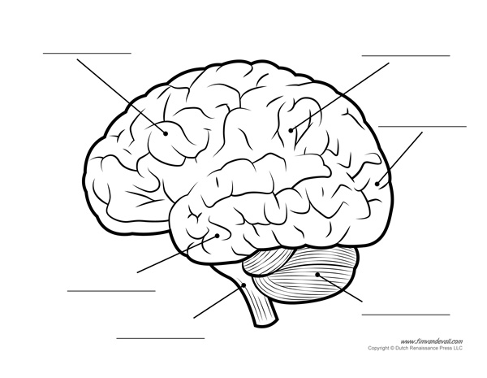
- The diagram below is of a nerve cell or neuron. Add the following labels to the diagram:
(1) Dendrites, (2) Cell body, (3) Soma, (4) Myelin sheath
2. Add labels for:(5) Axon, & (6) Axon terminals
3. Color: Dendrites – green, Cell body – blue, Soma – Red, Myelin sheath – yellow,
Axon – purple, Axon Terminals – orange
