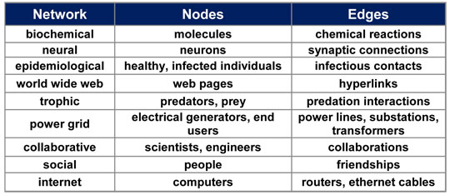

|  |  |
| --- | --- |
| **Node** | **# of Edges** |
|  |  |
|  |  |
|  |  |
|  |  |
|  |  |

**Example 1: Write down the node number with the number of edges (connections) per each node.**

**Draw and label a histogram of the Node vs Edges. Which is the Responding Variable? Which is the Manipulated Variable? (Remember, the Responding (Dependent) Variable goes on the y-axis and the Manipulated (Independent) Variable goes on the x-axis.)**

**Histogram: A *type of graph of data using bars of different heights. A*histogram*groups numbers into ranges (ex: 0-5, 6-10, 11-15). The height of each bar shows how many data points fall into each range. In a histogram there are no gaps between each bar.***

**Questions:**

1. **How many nodes are there in the diagram? ______________________**
2. **Which node(s) has the highest degree (degree = # of edges)? __________________**
3. **Which node(s) has the lowest degree? _____________________**

**Example 2:**

|  |  |
| --- | --- |
| **Node** | **Degrees (# edges)** |
|  |  |
|  |  |
|  |  |
|  |  |
|  |  |
|  |  |
|  |  |
|  |  |

**Draw and label a histogram of the Node vs edges.**

**Questions:**

1. Which node is the most important? Why? ________________________________________________________________________________________________________________________________________________________________________________________________________________________________________________________________________________________________
2. Which node is the second most important? Why? ________________________________________________________________________________________________________________________________________________________________________________________________________________________________________________________________________________________________
3. Which node is the least important? Why? ________________________________________________________________________________________________________________________________________________________________________________________________________________________________________________________________________________________________

**Example 3:**

**Computer networks are similarly connected. Complete the table below for the given office diagram:**

|  |  |  |  |
| --- | --- | --- | --- |
| **Node** | **Degree** | **Node** | **Degree** |
| **1** |  | **11** |  |
| **2** |  | **12** |  |
| **3** |  | **13** |  |
| **4** |  | **14** |  |
| **5** |  | **15** |  |
| **6** |  | **16** |  |
| **7** |  | **17** |  |
| **8** |  | **18** |  |
| **9** |  | **19** |  |
| **10** |  |  |  |

**Questions:**

1. What is the most important part(s) of this network? Explain your answer. ________________________________________________________________________________________________________________________________________________________________________________________________________________________________________________________________________________________________________________________________________
2. What are the least important part(s) of this network? Explain your answer. ________________________________________________________________________________________________________________________________________________________________________________________________________________________________________________________________________________________________________________________________________
3. Suppose Server N6 stops working. What effect will this have on computer N16? On Printer N14? Explain. ________________________________________________________________________________________________________________________________________________________________________________________________________________________________________________________________________________________________________________________________________

**Extension:**

1. Draw an edge between Server N12 and computer N16. If Server N6 stops working, what impact will the new connection have on Computer N16? __________________________________________________________________________________________________________________________________________________________________________________________________________________________________________________________________________________________________________________________________________________________________________________________________________________________